**Activity 14.2 - Mohammed Abdin**

**Submission Instructions:**

Your submission for this assignment should be a Word document that includes the following screenshots, each labelled for the step that the screenshot represents:

1. Provide a screenshot to show that the Java Docker *container* named javamaven has been created on port 8080.



1. Provide a screenshot to show that the javamaven *container* CLI has been updated.

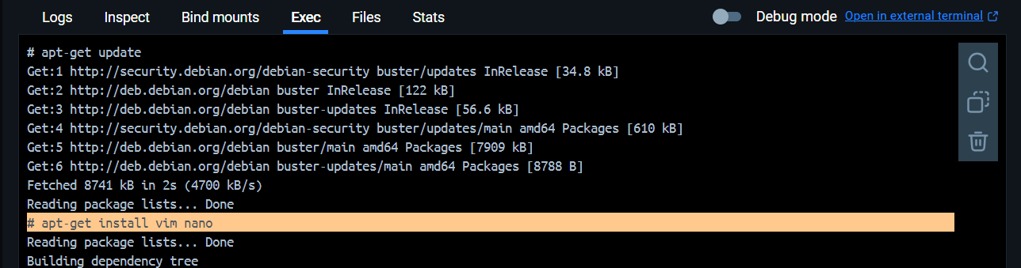

1. Provide a screenshot to show the Spring Initializr webpage with the correct settings selected.

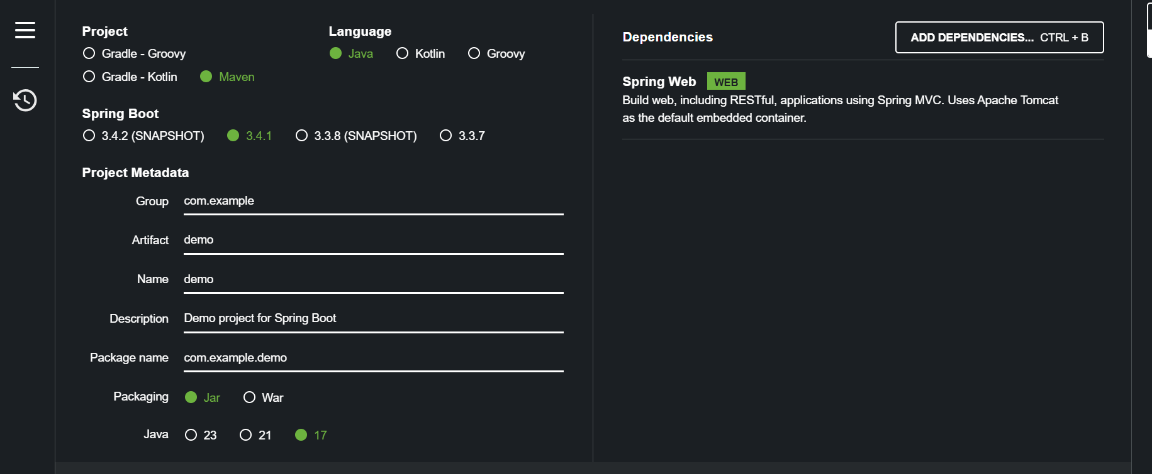

1. Provide a screenshot of the unzipped demo.zip folder.

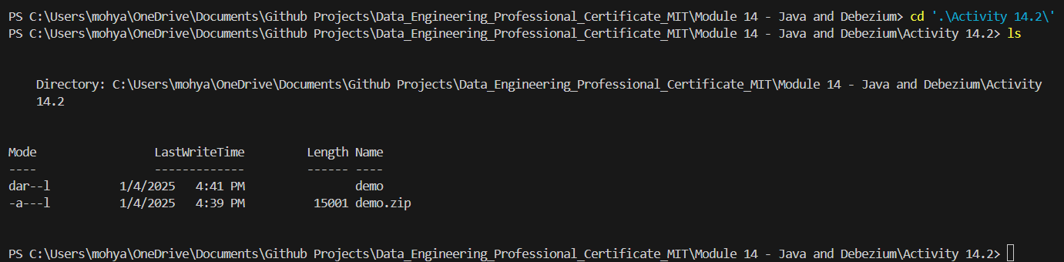

1. Provide a screenshot of the folder that shows the upload files.

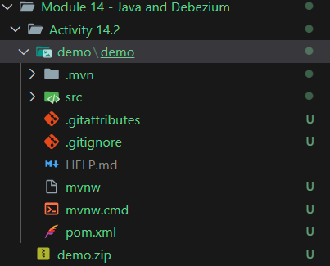

1. Provide a screenshot to show that you ran the docker cp command to upload files into the javamaven *container* home folder.



1. Provide a screenshot to show that the files from your local machine demo folder successfully uploaded to the javamaven *container*.

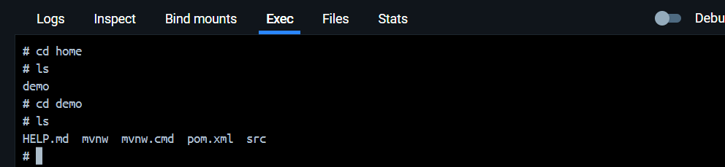

1. Provide a screenshot to show the DemoApplication.java file.

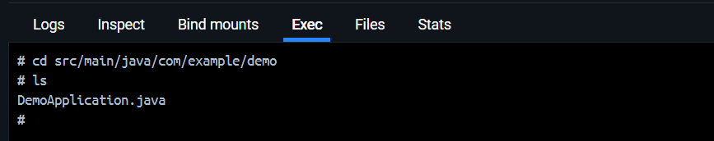

1. Provide a screenshot to show that the code in the DemoApplication.java file was updated successfully.

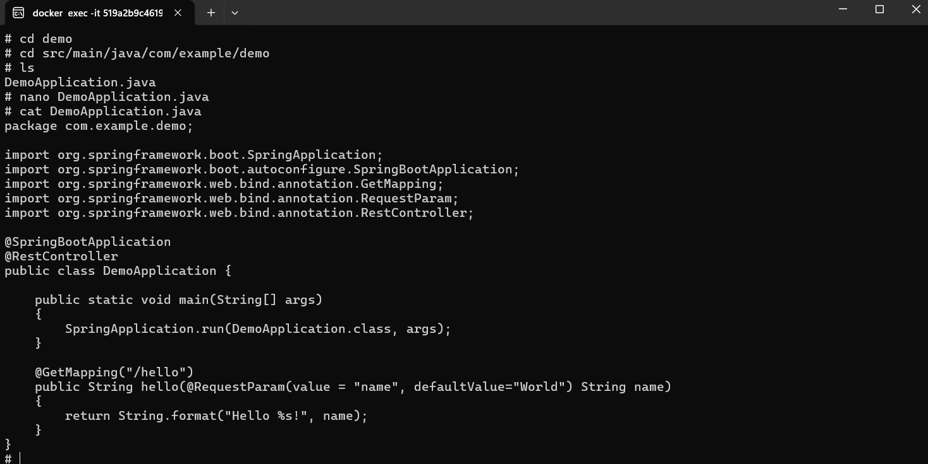

1. Provide a screenshot to show that the Java web application that you have created running.

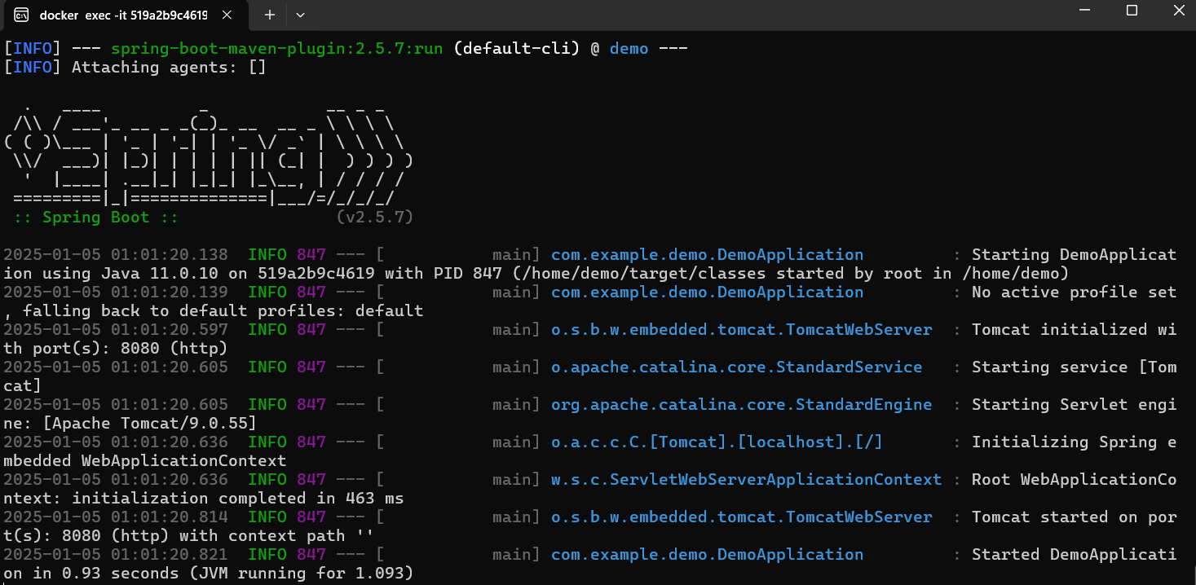

1. Provide two screenshots. One screenshot should show that you were successfully able to navigate to localhost:8080/hello. The second screenshot should show that you were successfully able to navigate to localhost:8080/hello?name=John.

